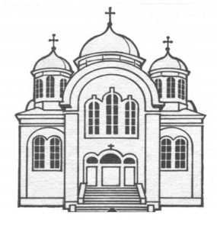

Українська Православна Катедра Святої Софії
Saint Sophie Ukrainian Orthodox Cathedral
Cathédrale orthodoxe ukrainienne Sainte-Sophie
6250, 12e avenue, Montréal (Québec) H1X 3A5

BAPTISMAL APPLICATION FORM

PLEASE NOTE INFORMATION MUST BE PROVIDED IN ENGLISH FOR OFFICIAL DOCUMENTS

Parents must arrange a personal meeting with Fr. Volodymyr (514-947-2235) to secure date and prerequisites for the baptism. Godparents must be practicing Orthodox Christians. Baptizing a child in the Orthodox Church presupposes that the child will be raised as an Orthodox Christian.

IMPORTANT: YOU MUST PROVIDE A COPY OF THIS FORM WITH THE BIRTH CERTIFICATE TO THE PRIEST PRIOR TO THE BAPTISM

Date of Baptism (month/day/year):________________________ Time:_________________

CHILD:
Family Name:_____________________________ Given Name:_______________________

Date of Birth (month/day/year):_________________ Place of Birth:______________________

PARENTS:
ADDRESS:__________________________________________City:____________________

Postal Code:____________________ Home Phone Number: _________________________

FATHER:
Name:__________________________________________Religion:_____________________

Place of Birth:________________________________ Cellular:_________________________
_
Email:________________________________________

MOTHER:
Maiden Name:_______________________________________Religion:_________________

Place of Birth:________________________________ Cellular:_________________________

Email:________________________________________

GODFATHER:
Name:__________________________________________Religion:_____________________

Place of Residence:________________________________

GODMOTHER:
Name:__________________________________________Religion:_____________________

Place of Residence:________________________________

SUGGESTED CONTRIBUTION FOR NON-MEMBERS - $150.00

Amount of Contribution: _____________________
Online contributions can be made by visiting canadahelps.org

Honorarium for the Parish Priest is customary, but at your discretion.

